美国叶史瓦大学大学陈文雄教授学术报告
报告题目： From Einstein's General Relativity to Curvature on Riemannian Manifolds
主讲人：陈文雄教授
时间： 2013年6月9日 星期日 15：30
地点：理化楼401
报告内容简介：
According to Einstein, the Universe we live in is bent or curved. Based on this, many scientists believe that the Universe is finite (in volume and mass), but endless ( there is no edge or boundary ).
How can a finite space be endless?
And how to measure the extent of bending?
In this talk, I will use simple examples to illustrate the answers to these questions and introduce the corresponding concepts of Riemannian manifolds and curvatures. I will try to be as intuitive as possible, so that general undergraduate students with basic knowledge on calculus can follow.
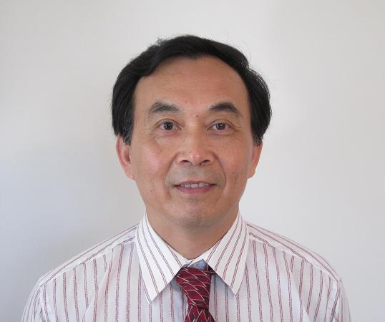
报告人简介：
陈文雄教授于1987年和90年先后任美国宾夕法尼亚州大学和亚利桑那大学的访问助理教授，1998年为美国加州大学访问副教授，2002年为美国密苏里州大学数学系教授，现为美国叶史瓦大学数学系教授。陈文雄教授是偏微分方程和几何分析的杰出专家，研究领域包括非线性偏微分方程、几何分析、泛函分析。任Communication on Pure and Applied Analysis 编委。在Annals of Math, J.Diff.Geom, Comm.Pure and Appl. Math, Duke Math. J, Advances in Math, Arch. Rat. Mech.Anal, J. Diff. Equa, Trans. AMS等期刊发表论文50余篇。

注：听报告的学生请携带校园卡记录创新学分

